Computer vision tutorials

Computer vision v/s Machine vision

Machine vision
- Practical usage of vision based systems in manufacturing, quality control settings etc
- We involve hardware along with software systems

Computer vision
- We already have videos -> frames = Input
- We develop algorithms / ML models / rule based systems for different tasks like facial recogn etc
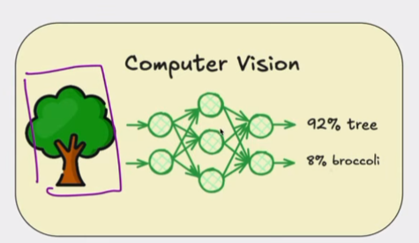

Model can be ML or non-ML model

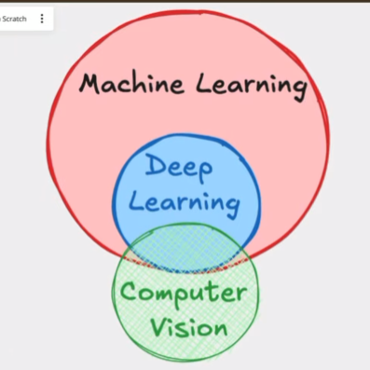
There are many techniques in CV which do not need ML
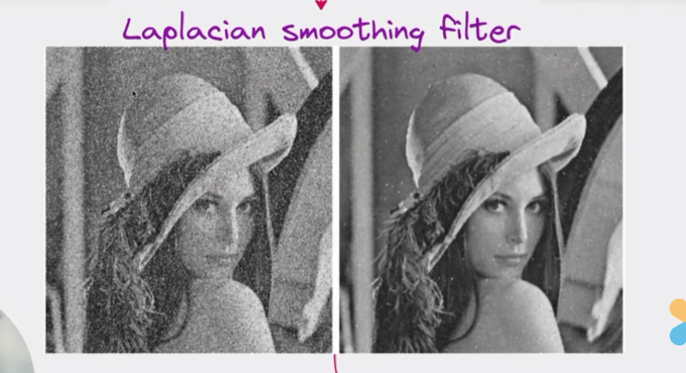

Left image is noisy. But we apply laplacian smoothing filter to smooth out the image.
Filters are also called Kernels. These kernels are a small grid of numbers. They slide over the image to change the pixel values based on their neighbours.
The better the filters, the better it is to process the pixels.

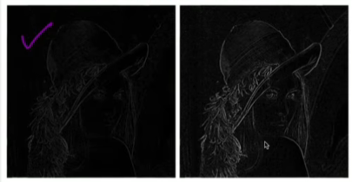

Laplace Edge Detector > Kernel is helping me detect edges.

How filters work ?

White pixels = 1, black pixels = 0
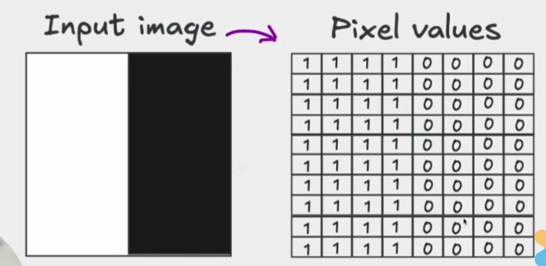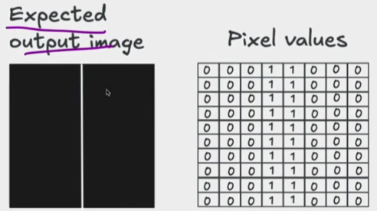

What kind of filter can help us achieve the expected output image
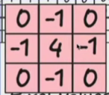

Input = 8 * 8 ; Kernel = 3 * 3
We are moving the kernel through the image and we are trying to calculate the output pixel values inorder to get the output pixel values. So we add padding if kernel is going out of the image boundary.
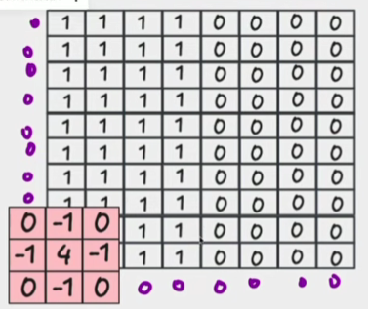 = OUTPUT AFTER APPLYING THE KERNEL
We multiply corresponding elements and add together. Finding the pixel value using the kernel

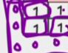 0*0 + -1 + 0 + 0+ 0 +

Edges means there is a change in the pixel value. So what these Laplacian or sober edge detection algorithms do is that wherever there is a sudden change in the pixel values then there it ll detect and highlight. If there is a full white or a full black then no edge will be detected or no line will be detected. Only change from white to black or black and white transition will get detected and highlighted.

Why did we come up with that specific filter?
We came up with a filter in such a way that whenever there is no edge the output should be 0.

But Rule based systems had to consider a lot (millions) of edge cases. Different type of edges etc. We had to come up with separate rules for each edge case. In ML we let the ML model figure out the logic using data. ML -> Deep learning -> Deep CNN

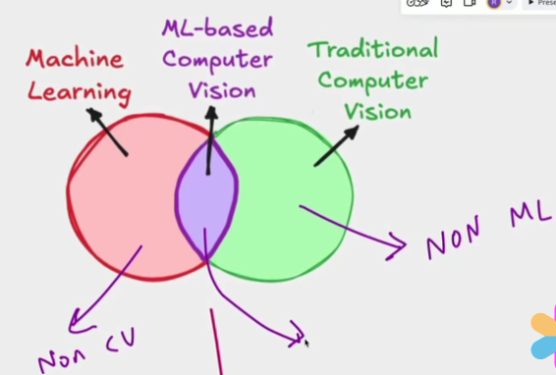

ML Based CV

LLM was only asked to learn to predict the next word. Nothing is precoded or rule based .
In ML based CV -> we dont explicitly define a rule to detect an edge or a tail. This is why systems are so efficient.

OCR (Optical Character Recognition) -> Digitizing a textbook
- Traditionally
  - We had to figure out how to remove noise
  - How to extract groups of words or sentences. Make a filter move from top to bottom or left to right.
  - Extract groups of words or sentences from the image. We make a filter move from top to bottom or left to right.
  - We need to have rules defined which say if there are spaces between the words then treat them as different words instead of a single word.
  - Once words are identified figure out how to split a word into individual letters.
  - Define rules like if there is a vertical line and a circle at the top then it will be d or p or b like that again rules to differentiate those.
This is why its very inefficient and mostly the systems were very bad.

- Rule-based heuristic systems
  - Handcrafted rules -> Rules for every case and shape
  - Decision Trees -> Decision trees were used to these rules defined. Like for example whether the character has a closed loop or not Yes and No branches.

But one character can be written in many different ways also. But a rule based system will not be able to recognise.
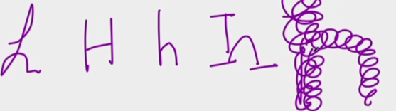

Problems of rule based
- So variability in font style and size was an issue
- When we scan the book the image quality might vary and also when we scan the letters in the edges of the book might not be very clear or they might be curvy so detecting the letters on that edge is difficult.
- The old book might have some spots or something
- Handwritten text v/s printed text. Handwritten text is difficult
- Background might not be fully white
- Language and script diversity -> If we are looking at some other language then it is an issue
- Overlapping or connected characters -> Like in cursive handwriting letters are a bit connected or overlapped.
- Color and contrast issues ->
- Special characters, etc

AlexNet
- Architecture that changed the history of computer vision.
- Based on Deep Convolutional Neural Network used for ImageNet classification.
- ImageNet is a benchmark dataset that models can use for classification so if your ML model performs well with ImageNet data then you have a very good ML model. AlexNet won the ImageNet challenge.
- Convolution, Maxpooling, etc
- What did they accomplish?
  - Massive performance improvement in ImageNet challenge by huge margin with high accuracy
  - Deep Neural networks became mainstream and Deep learning outperformed all the traditional methods like SVM, random forests etc.
  - Paper showed that We could increase the training speed by using GPU.
  - Introduced many things 👍
    - RELU instead of Sigmoid / tanh
    - Dropout regularisation - reduced overfitting
    - Overlapping max pooling -. Improved feature extraction
    - Data augmentation techniques - random cropping, mirroring, rotation
  - Deep Learning took over Computer vision
    - Deep learning expanded to NLP, robotics, healthcare etc.

Machine learning v/s Deep Learning

ML models -> DT, RF, SVM, LR, -> we need to feed the model with features.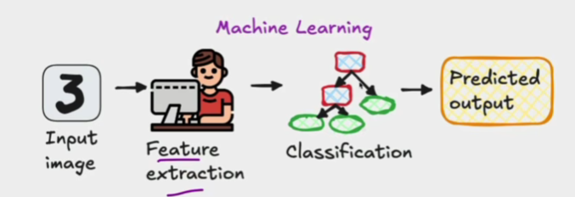

Deep Learning
We dont provide any features or do feature extraction here.
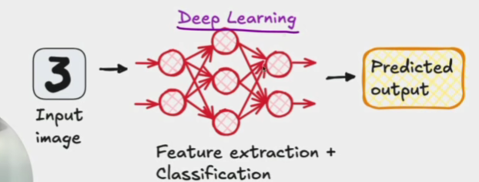

- We have the deep neural network with multiple hidden layers which automatically does feature extraction and classification.
- This makes deep learning much more powerful because manual feature extraction is difficult.
- The only thing we do in deep learning is train the deep learning network. If parameters/weights of deep learning model are good then the prediction will be very good. Otherwise we adjust the weights.
